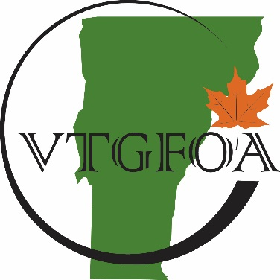

Vermont Government Finance

Officers Association
Organizational Meeting Minutes
June 20, 2017

Members present: Sarah Macy, Bill Hall, Cheryl Lindberg, John O’Connor and Susan Gage. Meeting was opened at 12:08 PM.

- Election of Officers for 2017/2018
President – Sarah Macy
1st Vice President – Wendy Wilton
2nd Vice President – Cheryl Lindberg
Treasurer – John O’Connor
Secretary – Susan Gage

- NESGFOA Representatives and National GFOA Representatives
NESGFOA representatives – Bill Hall, Cheryl Lindberg and Wendy Wilton
National GFOA – Bill Hall
- Treasurer’s Report
John presented an invoice from VLCT for renewal postage in the amount of $78.66. The invoice was approved for payment. John mentioned that we will probably have to send some membership money to NESGFOA as we have acquired some new members since their invoice. Cheryl stated that all states will be doing an annual reconciliation for this. Has not been done in the past, and has probably not been accurate. Another bill will be forthcoming from NESGFOA.
- Adjournment and Lunch
Meeting was adjourned at 12:15 pm.

Respectfully Submitted,

Susan Gage, VTGFOA Secretary

